**Advance Database Systems-CS 5600**

**FINAL REPORT**

**TITLE : BLOOD DONATION PORTAL**

**GROUP MEMBERS:**

ADUSUMILLI SWAPNA (700727297)

USHASWINI GOUD RESU (700728072)

VEENA SREE POOLA (700733833)

MEHAR KARTHIK VUNDAVALLI (700726079)

**What is the purpose of the database and why it is needed?**

My project is blood donation portal where user can book a slot for donating their blood. We are planning to use MONGODB as back-end in order to store all the user details, blood donation locations and the respective appointments for users.

**What should it do?**

The database acts as a repository to store all the website related details and the respective user insert, update, delete operations from the front end should reflect in the back-end as well in order to save the details.

**Who are the users and their information needs?**

The users are all the people who wants to book a slot in order to donate the blood. The only need here is to donate the blood

**What are the problems that the system should solve?**

The system should be able to save the slot details for all the users who wants to book a slot and it also have archive details of the old appointments history.

**What input data is available to the database?**

The input data available to database is

* User credentials for authentication
* Appointment details for saving appointment
* Donor id in order to get the donation history in the past
* Blood group in order to retrieve the donors with that blood group

**What kind of information should be stored in the database?**

This has no personal or confidential information except credentials.

Other than credentials we store the slot details for all the customers that have booked.

Front end and business logic implementation using **C#, HTML, CSS**

Back-end database implementation using **MongoDB**

**Operations:**

1. Login to the website
2. Can book appointment from website
3. Can delete an upcoming appointment from website
4. View the donation history
5. Get the donor details when providing blood group as input.

**Database description:**

Blood donation portal is a website mainly used for donors to schedule the slot for donating the blood. Below are the list of actors in the application

1. Donor
2. Doctor
3. Admin

All these actors have different options in the website once they login.

Below are the list of operations for each actor

**Donor:**

* View eligibility requirements
* Book a slot
* Delete a slot

**Doctor:**

* Search donors by blood group
* View statistics of donors registration

**Admin:**

* Add a new venue
* Create logins for doctors
* Add eligibility requirements
* View statistics

**Way of Working:**

Each donor will be registering to our website. Once they have registered then user credentials stored in the users collection. But for doctors we are not exposing registration to public. Instead we would reach out to admins in order to create logins for authorized doctors.

Once donor registers then he/she book slot for donating the blood. Each donor will have email, blood group, userid, password associated with them. Once a slot is booked the respective booking details stored in slots collection. Also donors can cancel their booked slot for any reasons.

As a doctor once we login we can search for any donors by blood group if there is any requirement for any patients in their respective hospitals. Also doctors have a feasibility to view all the donation registrations.

As a admin we can add a new donation venues if added in future and also they create logins for doctors as any user cannot be registered as a doctor. Only authorized ones should have doctor permissions and also admin can add any new eligibility requirements for donors in order to donate the blood and also view the stats of the registrations.

**Technologies used:**

* ASP.NET MVC
* MongoDB

Below are the list of the collections and their respective attributes in database

**Collection:** users

**Columns list:**

* userid
* password
* email
* bloodgroup
* usertype

This collection stores all the details of the users

**Collection:** eligibility requirements

**Columns list:**

* requirement

This collection stores all the eligibility requirements for the donors to donate the blood

**Collection:** slots

**Columns list:**

* slotid
* userid
* bookingdate
* venuename
* status

This collection stores the details of slot that donors have booked for donating the blood.

**Collection:** venues

**Columns list:**

* venueid
* name

This collection stores the details of the venues where donors can donate their blood

**Collection:** venues

**Columns list:**

* venueid
* name

This collection stores the details of the venues where donors can donate their blood

**Collection:** bloodbank

**Columns list:**

* id
* name
* address
* phone
* location
* website
* email

This collection stores the details of the Bloodbank.

**Collection:** bloodstock

**Columns list:**

* stockid
* bloodgroups
* status
* quantity
* bestbefore

This collection stores the details of the blood stock.

**Collection:** hospital

**Columns list:**

* hospitalid
* name
* address
* phonenumber
* website
* email
* location
* city

This collection stores the details of the hospital

**Collection:** medications

**Columns list:**

* medicationid
* name
* comments
* dose

This collection stores the details of the medications.

**Collection:** nurse

**Columns list:**

* id
* name
* section
* experience

This collection stores the details of the nurse

**All Collections view:**

**Database Diagram:**

|  |
| --- |
| **medications** |
| medicationid - int |
| name - string |
| comments - string |
| dose - string |

|  |
| --- |
| **Slots** |
| Slotid - int |
| userid - string |
| bookingdate - date |
| venuename - string |
| status - string |

|  |
| --- |
| **Users** |
| userid - string |
| password - string |
| email - string |
| bloodgroup - string |
| usertype - string |

|  |
| --- |
| **Bloodstock** |
| stockid - int |
| bloodgroups - string |
| status - string |
| quantity - float |
| bestbefore - int |

|  |
| --- |
| **Hospital** |
| hospitalid - int |
| name - string |
| address - string |
| phonenumber - string |
| website - string |
| email - string |
| location - string |
| city - string |

|  |
| --- |
| **Bloodbank** |
| id - int |
| name - string |
| address - string |
| phone - string |
| location - string |
| website - string |
| email - string |

|  |
| --- |
| **Venues** |
| venueid - int |
| name - string |

|  |
| --- |
| **nurse** |
| id - int |
| name - string |
| section - string |
| experience - int |

**User Interfaces and forms (Screen Shots)**

**Home page:**

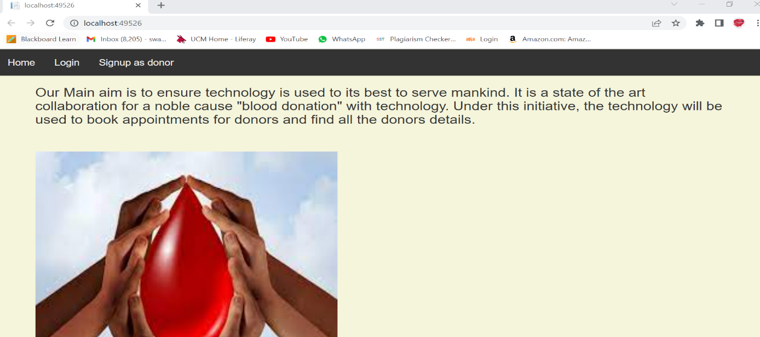

**Signup page:**

**User Login Page:**

**Donor Homepage:**

**Slot Booking:**

**Avoiding Duplicate Slots:**

**View Eligibility:**

**Delete A Slot:**

**Doctor Login:**

**Search For Blood Group:**

**Shows Donors with the requested blood group:**

**Doctors can see and update statistics:**

**Admin Login:**

**Admin Homepage:**

**Add a Venue:**

**Venue added to MongoDB:**

**Create a doctor entry:**

**Doctor data in MongoDB:**

**Add Donor eligibilities:**

**Eligibilities in MongoDB:**

**Admin Statistics:**

